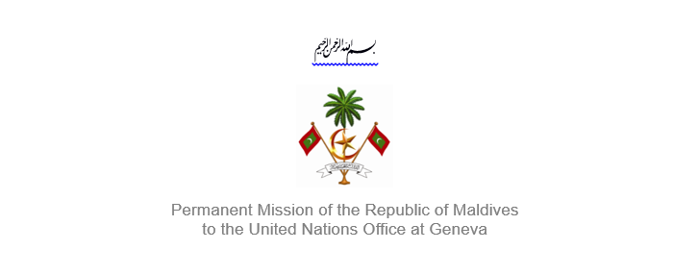
25th Session of the Working Group of the Universal Periodic Review
2 – 13 May 2016, Geneva

Review of Saint Vincent & the Grenadines
2 May 2016

Statement by:
Mr. Jeffrey Salim Waheed, Minister, Deputy Permanent Representative
of the Republic of Maldives to the United Nations Office at Geneva

Check against delivery

Thank you, Mr. President,

The Maldives extends a warm welcome to the delegation from St Vincent and the Grenadines to this review, led by our distinguished colleague, Her Excellency Ms. Rhonda King, Permanent Representative of the St. Vincent and Grenadines to the United Nations. My delegation offers its thanks for the comprehensive presentation provided and takes note of the national report. Additionally, we welcome efforts made to implement the recommendations that St. Vincent and the Grenadines received during its first cycle, despite the inherent challenges faced as a fellow Small Island Developing State (SIDS).

We are particularly encouraged by the adoption of a Domestic Violence Act in 2015 and believe that this represents significant forward momentum towards ensuring gender equality in the St. Vincent and the Grenadines. Further, we are pleased by the country enduring commitment to improving the standard of health for its people, including through the provision of free public healthcare for those aged 16 and under as well as a 100 percent vaccination rate of children.

Further, the Maldives makes the following recommendations:
- Review, adopt and implement the pending draft national policy on persons with disabilities to ensure non-discrimination in education, employment and healthcare; and
- Take appropriate steps to facilitate the adoption of legislation on gender equality.

As a fellow Small Island Developing State, the Maldives recognizes the difficulties faced by the St Vincent and the Grenadines in the field of development due to the ever present effects of climate change. We urge the State to continue seeking technical support and training in best practices from the United Nations and international community towards the promotion and protection of human rights in the country.

Lastly, as a long-time proponent of education and its value in a country, the Maldives appreciates the St Vincent & the Grenadines’ continued commitment to free and equal primary education.

The Maldives wishes the St Vincent and the Grenadines success during this review.

Thank you Mr. President.

